PO8_TheaterTickets

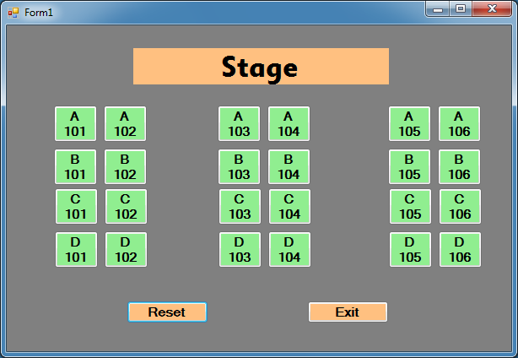

Private Sub btnExit_Click(sender As System.Object, e As System.EventArgs) Handles btnExit.Click

Application.Exit()

End Sub

Private Sub Button1_Click(sender As System.Object, e As System.EventArgs) Handles Button1.Click

Application.clear()

End Sub

Private Sub btn1_Click(sender As System.Object, e As System.EventArgs) Handles btn1.Click

btn1.BackColor = Color.LightPink

End Sub

Private Sub btn2_Click(sender As System.Object, e As System.EventArgs) Handles btn2.Click

btn2.BackColor = Color.LightPink

End Sub

Private Sub btn3_Click(sender As System.Object, e As System.EventArgs) Handles btn3.Click

btn3.BackColor = Color.LightPink

End Sub

Private Sub btn4_Click(sender As System.Object, e As System.EventArgs) Handles btn4.Click

btn4.BackColor = Color.LightPink

End Sub

Private Sub btn5_Click(sender As System.Object, e As System.EventArgs) Handles btn5.Click

btn5.BackColor = Color.LightPink

End Sub

Private Sub btn6_Click(sender As System.Object, e As System.EventArgs) Handles btn6.Click

btn6.BackColor = Color.LightPink

End Sub

Private Sub btn7_Click(sender As System.Object, e As System.EventArgs) Handles btn7.Click

btn7.BackColor = Color.LightPink

End Sub

Private Sub btn8_Click(sender As System.Object, e As System.EventArgs) Handles btn8.Click

btn8.BackColor = Color.LightPink

End Sub

Private Sub btn9_Click(sender As System.Object, e As System.EventArgs) Handles btn9.Click

btn9.BackColor = Color.LightPink

End Sub

Private Sub btn10_Click(sender As System.Object, e As System.EventArgs) Handles btn10.Click

btn10.BackColor = Color.LightPink

End Sub

Private Sub btn11_Click(sender As System.Object, e As System.EventArgs) Handles btn11.Click

btn11.BackColor = Color.LightPink

End Sub

Private Sub btn12_Click(sender As System.Object, e As System.EventArgs) Handles btn12.Click

btn12.BackColor = Color.LightPink

End Sub

Private Sub btn13_Click(sender As System.Object, e As System.EventArgs) Handles btn13.Click

btn13.BackColor = Color.LightPink

End Sub

Private Sub btn14_Click(sender As System.Object, e As System.EventArgs) Handles btn14.Click

btn14.BackColor = Color.LightPink

End Sub

Private Sub btn15_Click(sender As System.Object, e As System.EventArgs) Handles btn15.Click

btn15.BackColor = Color.LightPink

End Sub

Private Sub btn16_Click(sender As System.Object, e As System.EventArgs) Handles btn16.Click

btn16.BackColor = Color.LightPink

End Sub

Private Sub btn17_Click(sender As System.Object, e As System.EventArgs) Handles btn17.Click

btn17.BackColor = Color.LightPink

End Sub

Private Sub btn18_Click(sender As System.Object, e As System.EventArgs)

btn18.BackColor = Color.LightPink

End Sub

Private Sub btn19_Click(sender As System.Object, e As System.EventArgs) Handles btn19.Click

btn19.BackColor = Color.LightPink

End Sub

Private Sub btn20_Click(sender As System.Object, e As System.EventArgs) Handles btn20.Click

btn20.BackColor = Color.LightPink

End Sub

Private Sub btn21_Click(sender As System.Object, e As System.EventArgs) Handles btn21.Click

btn21.BackColor = Color.LightPink

End Sub

Private Sub btn22_Click(sender As System.Object, e As System.EventArgs) Handles btn22.Click

btn22.BackColor = Color.LightPink

End Sub

Private Sub btn23_Click(sender As System.Object, e As System.EventArgs) Handles btn23.Click

btn23.BackColor = Color.LightPink

End Sub

Private Sub btn24_Click(sender As System.Object, e As System.EventArgs) Handles btn24.Click

btn24.BackColor = Color.LightPink

End Sub

Private Sub btn18_Click_1(sender As System.Object, e As System.EventArgs) Handles btn18.Click

btn18.BackColor = Color.LightPink

End Sub

End Class